Newsletter 1 / January 2016

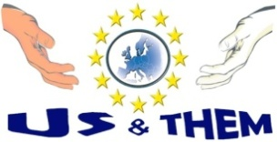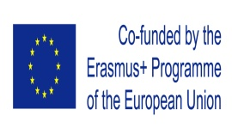**US & THEM:**

**dialog, tolerance, collaboration for good coexistence**

**in a multicultural world!**

**Project no : 2015-1ROO1-KA204-015131**

**NEXT STEPS**

**►**A Transnational Report will be prepared on the specific features of diverse European cultures and sub-cultures.

**►**The Italian partner(Staff Consult s.r.l.) will host the short-term joint staff training event, addressed to Adult Educators. The mobility training will last for 5 days and it will be held on the 15th-19th of February 2016 in Rome.

The Transnational Report and the short-term joint staff training of partners’ staff in Italy will serve as the basis for the curriculum development.

**KICK – OFF MEETING IN ROMANIA**

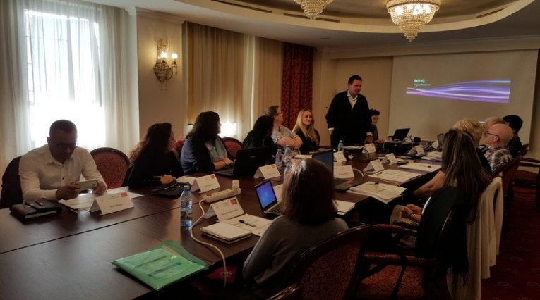

The partners had the first project meeting in Pitesti, Romania on 19-20th of November 2015. The purpose of the meeting was to establish a friendly environment for partners in order to share their ideas about the project establish a common understanding of terms and concepts and a unitary vision on activities.

The partners debated on some terms e.g. ‘adult educator’ which could possess various understandings and there were also considerations about the concepts of ‘culture’ and ‘religion’. Decisions were taken about the Curriculum for the mobility training of adult educators which will be held in Italy. One of the main discussions of the meeting was: *What the focus should be on?* Is it *culture* or *religion* that draws line and creates tension among the people? Are these concepts the same or they have a different meaning? The partners discussed on the topic and agreed to perform the field research in the area where they live. Another important issue that was approached referred to the Adult Educators who will be worked with in the project. It was pointed out on who the targets would be in each partner country. A profile concerning the Adult Education is needed (the system’s features at local and regional level, networks, cultural infrastructure, etc.) and will be achieved in each partner country.

The discussion continued with features of the research to be achieved. The questions *“Which are the skills of an AE educator?”* and *“AE in Europe in 2015”* (conflicts, European mobility, new policies & programs for migrants and refugees, labour market, etc.) were raised. Partners decided to use input from scientific papers, books and research findings (e.g. of the Dutch researcher and social psychologist Geert Hofstede and his *cultural dimensions* theory). In order to support the development of the second deliverable which will be the Curriculum for AE educators, *“Success factors in multicultural AE environments”* was another approached topic. Training needs of AE learners were discussed as they should be taken into consideration when designing the curriculum for AE educators.

**INTRODUCTION**

**Us&Them** is a two year Erasmus+ project aiming to train educators who are working with adults to promote tolerance and understanding of the ‘others’ in a multicultural world.

The Project will improve the multicultural skills of the educators from the field of Adult Education (AE) and will offer high quality learning opportunities for learners living in mixed communities. To create a multicultural and mixed group, the project is made up of 8 participating countries encompassing various traditions, cultures, religions, this way valorising experiences that belong to representative cultures: Christian, Muslims, Jewish, Hindu.

**Us&Them** project will strengthen education and training paths of AE educators and will help them develop a set of new skills and competences (especially soft skills in socio-cultural conflict management, multicultural skills development to adapt the learning environment to various cultures and backgrounds, skills on implementing positive attitudes toward language, race, cultural & ethnic diversity, skills on managing learners’ group diversity), needed to enable them to better manage and deal with their groups of adult learners in the field of living, working and getting integrated within nowadays multicultural societies/communities. The newly acquired competences will be used by AE educators to promote (among their learners) tolerance and understanding of “the other” in such communities.

**The target groups** to which the project addresses are Adult Educators and Adult Learners.

Diversity in Europe makes it a must to know and understand different traditions, religions and cultures. To live in a more peaceful environment and make Europe a friendly place, it becomes necessary to learn the skills to deal with the challenging situations faced in a multicultural environment. According to Eurostat (2014) there were 33.5 million people born outside of the EU-28 living in an EU Member State on January 2014, while there were 17.9 million persons who had been born in a different EU Member State from the one where they were resident. The co-existence of such diverse groups of people may serve as a source for conflict and the tension between these groups may seem to be unavoidable. However, the social tensions and anti-social deeds generated by multiple factors (i.e. different religious background, different cultural traditions, affiliation to different ethnicities or social clusters, etc.) can be defused and prevented through non-formal and informal education and training for tolerance, acceptance, opening, understanding and reciprocal knowledge, which is exactly what the Us&Them project intends to do.

**CONTACT US:**

**1. GRUPUL PENTRU INTEGRARE EUROPEANĂ**  [www.gie.ro](http://www.gie.ro)

*Georgeta Chirleşan [g.chirlesan@gie.ro](mailto:g.chirlesan@gie.ro)

**2. CENTRE FOR ADVANCEMENT OF RESEARCH AND DEVELOPMENT IN EDUCATIONAL TECHNOLOGY LTD** [www.cardet.org](http://www.cardet.org)

*Charalambos Vrasidas [pambos@cardet.org](mailto:pambos@cardet.org)

**3. FUNDACIÓN UNIVERSIDAD EMPRESA DE LA REGIÓN DE MURCIA**  [www.fuem.es](http://www.fuem.es)

*Consuelo García Sánchez [consugar@um.es](mailto:consugar@um.es)

**4. LOUTH AND MEATH EDUCATION AND TRAINING BOARD**

[www.lmetb.ie](http://www.lmetb.ie)

*Elizabeth Lavery [elavery@lmetb.ie](mailto:elavery@lmetb.ie)

**5.** **STAFF CONSULT** **S.r.l.** [www.staffconsult.it](http://www.staffconsult.it)

Francesco Lembo [lembo.francesco@gmail.com](mailto:lembo.francesco@gmail.com)

**6. ASSOCIAÇÃO NACIONAL PARA A ACÇÃO FAMILIAR**

[www.anjaf.pt](http://WWW.ANJAF.PT)

*Ana Sofia Da Silva [s.silva@anjaf.pt](mailto:s.silva@anjaf.pt)

**7. ÇAN İLÇE MILLI EĞITIM MÜDÜRLÜĞÜ** [www.can.meb.gov.tr](http://www.can.meb.gov.tr)

*Elif Soydemir [soydemirelif@yahoo.com](mailto:soydemirelif@yahoo.com)

**8. COLEG CAMBRIA** [www.cambria.ac.uk](http://www.cambria.ac.uk)

*Simon Hughes [Simon.hughes@cambria.ac.uk](mailto:Simon.hughes@cambria.ac.uk)

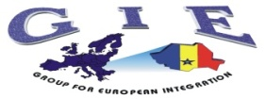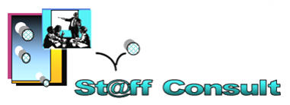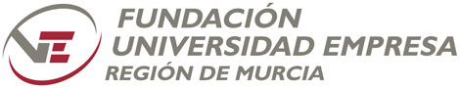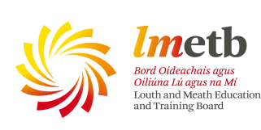

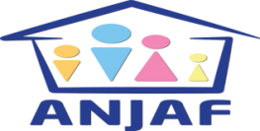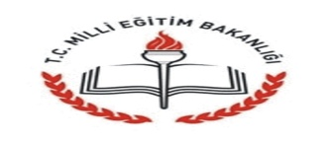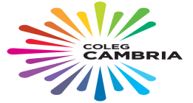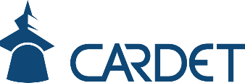

*‘’The European Commission support for the production of this publication does not constitute an endorsement of the contents which reflects the views only of the authors, and the Commission cannot be held responsi­ble for any use which may be made of the information contained therein."*

**Soon we will open the „Us&Them” website and Facebook page!**